Useful commands for Rails:

rails -v rails version
In root directory rails new -project_name- --database=postgresql creates a rails project with database lang of pgsql
bundle exec rails db:create creates the db
bundle exec rails g migration create_-table_name- Creates a folder and a file. The file will contain a basic script for creating a table. In this file, we specify what columns we want.
For instance:
t.string :name, null: false - creates a column called name, and gives it the property of a string
t.integer :location_id
t.timestamps

bundle exec rails g model model name plural
add pry-rails and better_errors
bundle exec rails db:migrate looks at our migrate folder, and runs any migrations that haven’t been run yet, which basically means it created the tables.

Bundle exec rails dbconsole drops you into your SQL manager where you can get access to the sql access to your tables/databases. Select * from -table- etc. However, the whole point of activerecord is that we don’t have to write a lot of SQL, particularly for routine things.

Models – create a new file inside your models folder named after your table, but in the singular form. This is very important so that Rails knows what you’re doing. The name of the class needs to be the same as your file name. And then you just make sure that the class inherits from ApplicationRecord, and that’s it. If you wanted to write any code that applied to every class (and therefore, every table), then you add things in the application record file/class. Self.abstract_class = true needs to be there so that it knows that it’s not actually a model.

Rails c drops you into the Rails console, which is like pry, but it loads all your databases/tables, files, and models for you. Awesome! You can type the name of a db, and it’ll give you the name of that database. You can say Class.new and set it to a variable, and you get an instance! You can name it.

In Rails c - instance.save inserts an instance of that class into its associated table.
In Rails c – Class.all calls Select * from table, but doesn’t produce an array. It produces what’s called a relation. You can also call Class.first, Class.second, Class.last, etc. You can also update information from Rails c, and it’ll delegate to new or update depending on whether or not it exists in the table. Pretty awesome
In Rails c - reload! Brings in any changes from the file, but you get to keep anything else that you’ve done in the irb

The difference between ! And non! On an instance is that if you save it with a bang, and it can’t save, it’ll raise an error. Regular save will return true or false, depending.

In Rails c – Class.create(options) This will create and save an instance into a table at the same time

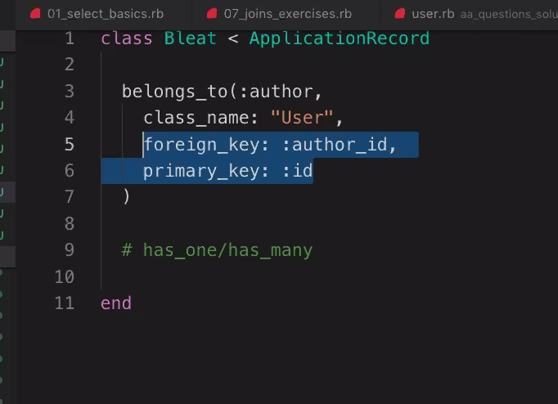
Associations – belongs_to or has_one/has_many. Whenever anything has a foreign key, it will belong_to something. Then, what we want to name the association, what the class name it belongs to is, it’s foreign_key, and it’s primary key.

This goes into models.

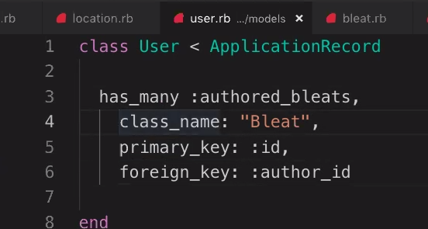
What to do if you forget an attribute – it is possible to revert a migration, but in general you never want to do that. Never do that. All you have to do is make a new migration that addresses those issues. It’s very common to have tons of migrations.

So, to come at this from the other direction, we can give an association to user: with this, we can make it so that an author has many authored bleats. Notice the has_many. The difference between has_many and has one is that has_one does a limit one and returns a single instance.

Now, the user class also belongs to a location, because the user class contains a foreign key for location.

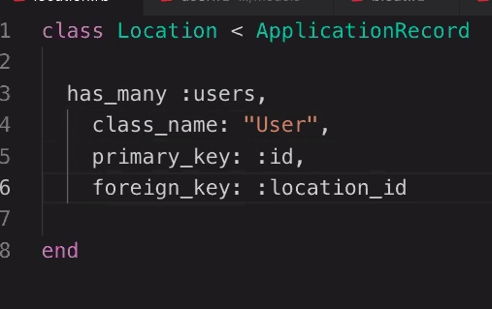

Location will have_many users, because the user has a foreign key for location, and a location is likely to have multiple users associated with it. The order of these items don’t matter, because it’s actually a hash.

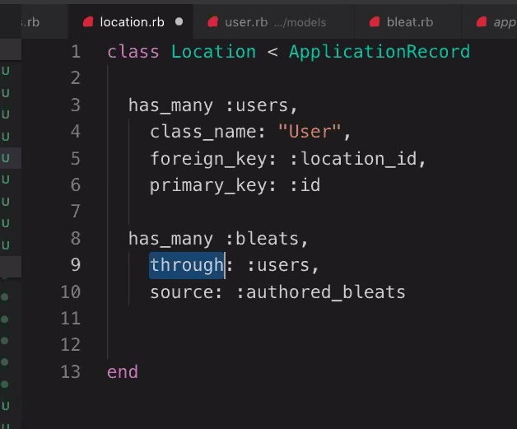

Location will also have many bleats, but it will have those bleats through the association of users, so there’s some special syntax that we use to make that association. Has many bleats, through users, and the source is how we make the jump from the current file to the user file. Think about it like the first jump and the second jump.

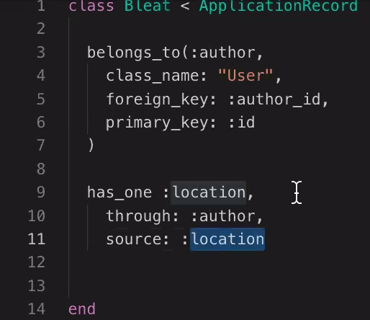

Also, if we wanted to make the jump from a bleat to its user’s location, it will have one, because a bleat can only be associated with a single location. So it has one location, through author, so it jumps to the author association, and then source to location.

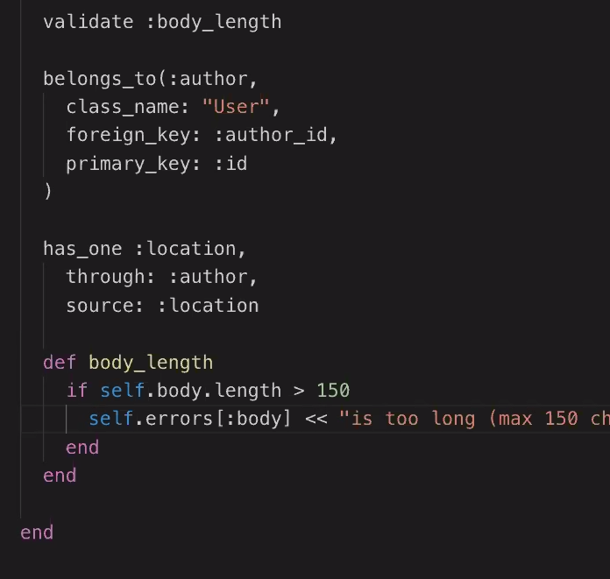
Validations – What are the cases in which a save! won’t be able to save something and therefore raise an error? That comes from a validation. For instance, if a string isn’t less than or equal to 150 characters, then that would be a validation that would throw an error if it didn’t pass the validation.

Notice that we put the validation at the top of the file, but we define the method of the validation at the bottom. To see the text of an error, you can call errors on an instance. We can check to see if an instance is valid to be saved: instance.valid? Note, that you can run .errors on a non_valid instance, but it won’t display the error unless you try to save it first.

Table names need to be pluralized. Always. This factors into the convention over configuration mentality of rails. Rails uses conventions to take care of the configuration stuff for us

Notes:

Bulk of the app lives in the app directory. Images might live in assets. Channels are about open streams of communication. Controllers are how we serve different pages up. Helpers is a spot where we can put modules. Jobs is for things that happen in the background. Mailers is if our app sends emails. Models are where we have our models like users and questions. Views is where we specify HTML and stuff like that.

Config is where the yml file lives, which is where we specify our databasing language. Development, test, and production are the three different environments in which our app can live. We need these three environments because there are some things that we want to behave differently based on where the app is operating.

Db directory is a big one.

Lib directory is a general miscellaneous place where we can put stuff that doesn’t belong anywhere else.

Log is where we keep track of everything that happens in our app.

Public is files that we can send to our users.

Storage is where we store files that our users upload. Actually pretty rare to use this. We typically use a different service.

Test is like the spec directory. Many different folders to organize our tests.

Tmp is storage for temp files that the app creates.

Vendor. Typically we use the Gemfile to store references to other people’s code. Vendor is another place we can store that when it isn’t a gem or hasn’t been made into a gem yet. Code that you could use that you didn’t write yourself.

Gemfile – bigger than we’re used to seeing. Lots of stuff specified. Like pg instead of sqlite3. A ton of things that just come in as default for rails.

Package JSON – used for java.

Rakefile is where we can create commands ourselves.

Readme. Where we explain a little bit about our app.

Schema file – contains a record of the tables that exist in our database so far, and what attributes are associated with those tables. Schema also has a version of the schema that represents the latest migration that was run. Rails keep track of which migrations have been run on each individual machine.

ActiveRecord -

criticisms – getting so wrapped up in the theory, the essentials are getting glossed over. i.e., if you want to do a join, say Class.join(“raw SQL for join, e.g. JOIN x on y = z”) in a string.
And then you just sort of do it chunk by chunk.

Now, we can replace these strings with associations (sometimes). It depends on whether you can replace the string with the hash symbol that represents it. There are some cases in which there just isn’t a symbol that you can use, so you have to use the string. For instance, with the LIKE operator. Conversely, .joins will only take an association.

If you want to do a double join, you need to use the hash syntax: left_outer_joins(users: :location)
How to create associations -

user doesn’t belong to anything, because it doesn’t have any foreign keys. Whenever you have an id in the table that isn’t your id, then that’s a foreign key. Responses has two foreign keys, which means that it belongs to two other tables: users, and answer choice. So, if response belongs to answer choice, then that means that answer_choice has many responses. If it’s a has many, it’s because the foreign key is in it’s own table, which means that is where the foreign key is found.

Answer choice Class
has_many => responses
foreign_key => answer_choice_id
#If it’s a has many, the foreign key will be whatever ID for this class is in the responses class

Answer choice Class
belongs_to question
foreign_key => question_id
#if it belongs to, the foreign key will be what it belongs to

Answer Choice Class
has_many :responses
through: :answer choices
source: :responses
#if you need to jump through, the through will be an association in the present model.
#the source will be an association in the class that you jumped to through the through association.

A through association must be a has_one or a has_many. It can’t be on a belongs to.

Be aware of optional: true. If an association isn’t passing, and you can’t figure out why. Try throwing in a optional: true. Only on belongs to.

